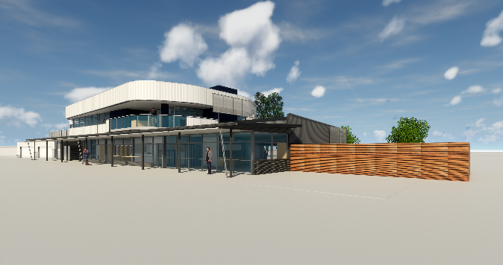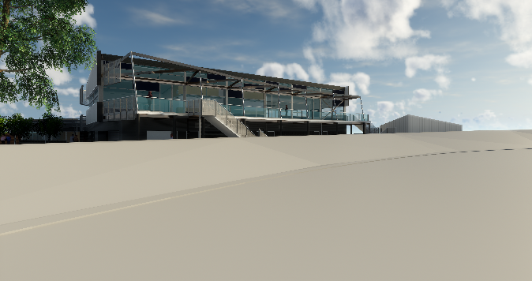

Edwardstown Soliders Memorial Recreation Ground

Board of Directors ( 8 to be appointed )

Founded in 1920 the Edwardstown Soliders Memorial Recreation Ground is a unique complex currently utilised by several sporting clubs & community groups. An $8.8M redevelopment is nearing completion with funding from City of Marion ($4M) and the Australian Federal Government ($4M).

The refurbished Edwardstown Soliders Memorial Recreation Ground will be a new breed of sports and community precinct that has been established with five clubs and associations who have made a commitment to work in partnership to create a stronger community for the future.

The Edwardstown Soliders Memorial Recreation Ground offers an exciting opportunity to lead change and transform sporting and community opportunities within the wider area. The collective approach aims to facilitate a multi purpose complex that offers a modern approcah to sports management and community service delivery for groups, associations and individuals.

The facility will be managed by committee with the day to day opertaions and management of the site undertaken by a full time Facility Manager who reports directly to the committee.

Nominations are currently sought for the 8 available positions on the committee.

To access the clubs constitution, position description, nomination forms please visit https://www.marion.sa.gov.au/edwardstown-oval-soliders-memorial-ground For any enquiries or further information please contact or email James O’Hanlon on james.ohanlon@marion.sa,gov.au or 0466 432 894.

Aplications close 5pm Friday, 14th December

