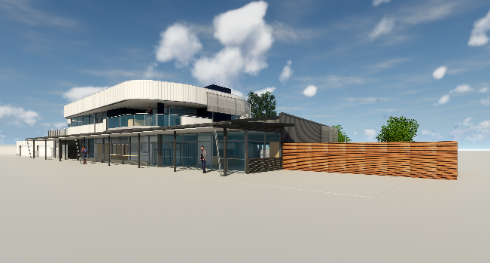
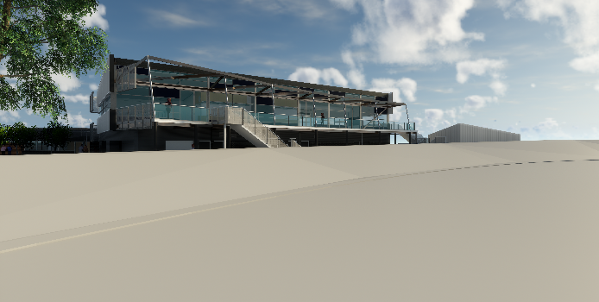
Edwardstown Soldiers Memorial Recreation Ground Board Member Nomination Form

Candidate Information

Name …………………………………………………………………………………………………………

Home Address ………………………………………………………………………………………………...

Phone Number (W)……………………………………. (M)………………………………….......................

E-mail ………………………………………………………………………………………………………….

Current Employment / Position ……………………………………………………………........................

Education …………………………………………………………………………………………………

Previous Committee / Board experience …………………………………………………………………….

…………………………………………………………………………………………………………...............

…………………………………………………………………………………………………………………….

……………………………………………………………………………………………………………………

Please circle any of the following skills or experience that candidate possesses

Finance / Accounting Management / Administration
Grant writing Non Profit experience
Fundraising / Special events Report Writing / Document Preparation
Public relations / Communications Contacts / Networking

Other……………………………………… Other…………………………………….

Affiliations or organizations the candidate belongs to (Professional / Civic / Memberships)

………………………………………………………………………………………………………………………

………………………………………………………………………………………………………………………

………………………………………………………………………………………………………………………

………………………………………………………………………………………………………………………

Statutory Declaration

Each nominee for election to the board shall complete the following statutory declaration.

This checks compliance with key legislative requirements for holding a director’s position.

I ( name ) ………………………………………………………………………………………………

Of ( address )…………………………………………………………………………………………..

Solemnly declare as follows:

- I am the person nominated for position of office within the (ESMRG).
- I am not currently under suspension form any of the associated clubs or organisations
- I am not an undischarged bankrupt under the law of Australia
- I am not disqualified from managing a corporation under the Corporations Act
- I am aware that if I become a director of ESMRG I will have duties and responsibilities at law

Nominee …………………………………………….

Signature …………………………………………….

Date ……………/……………./……………….

Please return completed form via email to James O’Hanlon at james.ohanlon@marion.sa,gov.au or post to PO Box 21, Oaklands Park SA 5046 or drop into City Services reception at 935 Marion Road, Mitchell Park.

Aplications close 5pm Friday, 14th December

